|  |
| --- |
| CGI |
| LAB REPORT |
| LAB-3 |
|  |
| **SWET SHEERSH** |
| **7/25/2023** |

|  |
| --- |
| This report contains lab 3(1 to 4) codes and their output snapshots. |

3.1.

**package** lab1_1_6;

**public** **class** MyException **extends** Exception {

@Override

**public** String toString() {

**return** "Invalid Input";

}

}

**package** lab1_1_6;

**public** **class** Person {

**private** String firstName;

**private** String lastName;

**private** **char** gender;

//getter setter

**public** String getFirstName() {

**return** firstName;

}

**public** **void** setFirstName(String firstName) {

**this**.firstName = firstName;

}

**public** String getLastName() {

**return** lastName;

}

**public** **void** setLastName(String lastName) {

**this**.lastName = lastName;

}

**public** **char** getGender() {

**return** gender;

}

**public** **void** setGender(**char** gender) {

**this**.gender = gender;

}

//default constructor

**public** Person() {

**super**();

// **TODO** Auto-generated constructor stub

}

//parameterize constructor

**public** Person(String firstName, String lastName, **char** gender) {

**super**();

**this**.firstName = firstName;

**this**.lastName = lastName;

**this**.gender = gender;

}

@Override

**public** String toString() {

**return** "Person [firstName=" + firstName + ", lastName=" + lastName + ", gender=" + gender + "]";

}

}

**package** lab1_1_6;

**public** **class** PersonMain {

**public** **static** **void** main(String[] args) **throws** MyException {

Person obj=**new** Person("","Bharathi",'F');

**try** {

**if**(obj.getFirstName()=="" || obj.getLastName()=="") {

**throw** **new** MyException();

}

} **catch** (Exception e) {

// **TODO**: handle exception

e.printStackTrace();

}

System.***out***.println("Person Details:");

System.***out***.println("-----------------");

System.***out***.println("First Name: "+obj.getFirstName());

System.***out***.println("Last Name: "+obj.getLastName());

System.***out***.println("Gender: "+obj.getGender());

}

}

Result:

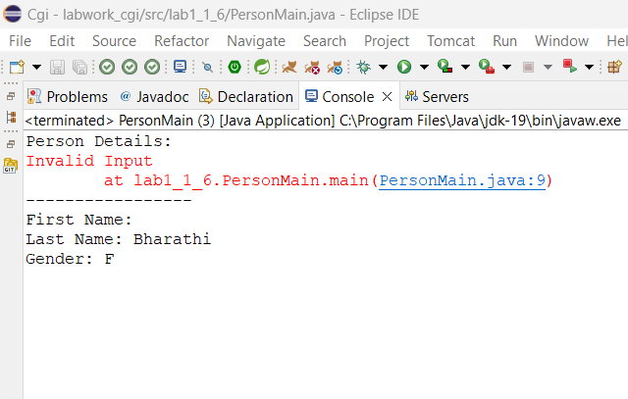

3.2

**package** lab2_1;

**public** **class** Person {

String name;

**float** age;

**public** String getName() {

**return** name;

}

**public** **void** setName(String name) {

**this**.name = name;

}

**public** **float** getAge() {

**return** age;

}

**public** **void** setAge(**float** age) {

**this**.age = age;

}

**public** Person() {

**super**();

// **TODO** Auto-generated constructor stub

}

**public** Person(String name, **float** age) {

**super**();

**this**.name = name;

**this**.age = age;

}

@Override

**public** String toString() {

**return** "Person [name=" + name + ", age=" + age + "]";

}

}

package lab2_1;

import java.util.ArrayList;

import java.util.HashMap;

public class AccountMain {

public static void main(String[] args) throws Exception{

System.out.println("Lab 2 -> Question No.:1-A");

System.out.println("+++++++++++++++++++++++++++");

// TODO Auto-generated method stub

AccountMethod method =new AccountMethod();

HashMap<String, AccountDetail> map=new HashMap<String, AccountDetail>();

//smith qAccount creation

AccountDetail detail1=new AccountDetail();

Person p=new Person();

p.setName("smith");

p.setAge(14);

detail1.setAccHolder(p);

detail1.setAccNum(method.generateAccNum());

detail1.setBalance(2000);

map.put("smith", detail1);

try {

if(detail1.getAccHolder().getAge()<15) {

throw new AgeException();

}

} catch (Exception e) {

// TODO: handle exception

e.printStackTrace();

}

System.out.println(detail1);

System.out.println("--------------------------------------");

//kathy account creation

AccountDetail detail2=new AccountDetail();

Person p1=new Person();

p1.setName("kathy");

p1.setAge(22);

detail2.setAccHolder(p1);

detail2.setAccNum(method.generateAccNum());

detail2.setBalance(3000);

map.put("kathy", detail2);

System.out.println(detail2);

System.out.println("--------------------------------------");

System.out.println("Lab 1 -> Question No.:1-B");

System.out.println("+++++++++++++++++++++++++++");

map.get("smith").setBalance(method.deposit(2000,map.get("smith").getBalance()));

System.out.println(map.get("smith"));

System.out.println("--------------------------------------");

System.out.println("Lab 1 -> Question No.:1-C");

System.out.println("+++++++++++++++++++++++++++");

map.get("kathy").setBalance(method.withdraw(2000,map.get("kathy").getBalance()));

System.out.println(map.get("kathy"));

}

}

**package** lab2_1;

**import** java.util.Random;

**public** **class** AccountDetail {

//parameters

**private** String accNum;

**private** Person accHolder;

**private** **int** balance;

//getters and setters

**public** String getAccNum() {

**return** accNum;

}

**public** **void** setAccNum(String accNum) {

**this**.accNum = accNum;

}

**public** Person getAccHolder() {

**return** accHolder;

}

**public** **void** setAccHolder(Person accHolder) {

**this**.accHolder = accHolder;

}

**public** **int** getBalance() {

**return** balance;

}

**public** **void** setBalance(**int** balance) {

**this**.balance = balance;

}

//default constructor

**public** AccountDetail() {

**super**();

// **TODO** Auto-generated constructor stub

}

//Parameterized constructor

**public** AccountDetail(String accNum ,Person accHolder, **int** balance) {

**super**();

**this**.accNum = accNum;

**this**.accHolder = accHolder;

**this**.balance = balance;

}

//tostring

@Override

**public** String toString() {

**return** "AccountDetail [accNum=" + accNum + ", accHolder=" + accHolder + ", balance=" + balance + "]";

}

}

**package** lab2_1;

**import** java.util.Random;

**public** **class** AccountMethod {

**private** **final** **int** MIN_BALANCE=500;

**public** **int** deposit(**int** amount,**int** balance) {

**if** (amount >= 0) {

balance += amount;

**return** balance;

}

**return** balance;

}

**public** **int** withdraw(**int** amount,**int** balance) {

**if** (amount > 0 && balance - amount >= MIN_BALANCE) {

balance -= amount;

**return** balance;

}

**return** balance;

}

//account number

**public** String generateAccNum() {

Random random = **new** Random();

**return** String.*format*("%09d", random.nextInt(1000000000));

}

}

**package** lab2_1;

**public** **class** AgeException **extends** Exception {

@Override

**public** String toString() {

**return** "sorry!! you are below 15";

}

}

Result :

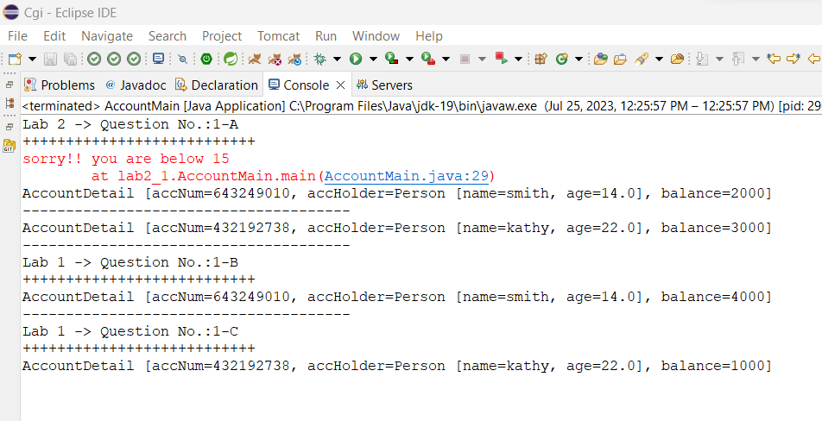

**3.3.**

**package** com.cg.eis.exception;

**public** **class** EmployeeException **extends** Exception {

@Override

**public** String toString() {

**return** "Invalid sallary input!! Below 3000 Not Allowed";

}

}

package com.cg.eis.pl;

import java.util.Scanner;

import com.cg.eis.bean.Employee;

import com.cg.eis.exception.EmployeeException;

import com.cg.eis.service.EmployeeService;

import com.cg.eis.service.EmployeeServiceImpl;

public class EmployeeMain {

public static void main(String[] args) throws Exception {

Scanner sc = new Scanner(System.in);

EmployeeService employeeService = new EmployeeServiceImpl();

System.out.println("Enter Employee Details:");

System.out.print("ID: ");

int id = sc.nextInt();

sc.nextLine(); // Consume the new line character left by nextInt()

System.out.print("Name: ");

String name = sc.nextLine();

try {

System.out.print("Salary: ");

double salary = sc.nextDouble();

sc.nextLine(); // Consume the new line character left by nextDouble()

throw new EmployeeException();

} catch (Exception e) {

// TODO: handle exception

e.printStackTrace();

}

System.out.print("Salary: ");

double salary = sc.nextDouble();

sc.nextLine(); // Consume the new line character left by nextDouble()

System.out.print("Designation: ");

String designation = sc.nextLine();

Employee employee = new Employee(id, name, salary, designation);

employeeService.getEmployeeDetails(employee);

System.out.println("\nInsurance Scheme Details:");

employeeService.displayEmployeeDetails(employee);

sc.close();

}

}

Result:

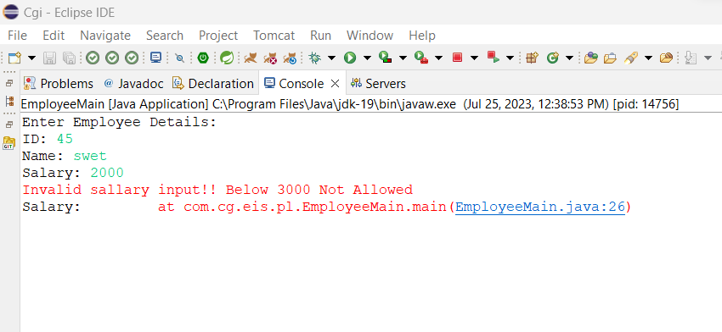

3.4.

**package** lab3_4;

**import** java.util.Arrays;

**public** **class** ProductNamesSorter {

**public** **static** **void** main(String[] args) {

// Sample product names

String[] productNames = {

"Keyboard",

"Monitor",

"Mouse",

"Laptop",

"Headphones"

};

System.***out***.println("Original product names:");

*printProductNames*(productNames);

// Sorting the product names

Arrays.*sort*(productNames);

System.***out***.println("\nSorted product names:");

*printProductNames*(productNames);

}

**public** **static** **void** printProductNames(String[] productNames) {

**for** (String name : productNames) {

System.***out***.println(name);

}

}

}

Result:

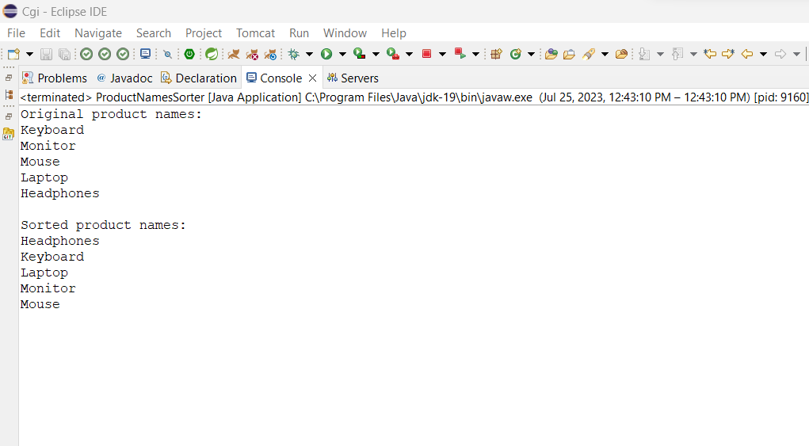

Thank You…